**INTRODUCTION**

Our app idea is a social media cooking app where users are exposed to an interactive cooking feed. The aim of the social media cooking app is to not only encourage users to gain more experience in the kitchen, but also to make mealtimes fun and exciting, all whilst taking into consideration factors such as income and dietary requirements.

For stage B, our group collected data about our users to try and understand their habits and preferences and in particular, problems and challenges they faced in regard to meal prep and cooking at home. Stage C involved using our findings and Usability models to produce a series of quick sketches which had the aim of attempting to solve user’s primary problem: _____

In this report, we draw from those sketches and the theory of Usability, to produce a final, high-fidelity prototype. In the next stage of this project, we will conduct an evaluation of that prototype.

**REFELCTIONS ON EXISTING SKETCHES**

The first step involved figuring out which elements from the design sketches we wished to incorporate into the final prototype. This meant looking through the sketch designs and deciding on positive features, i.e. features that encapsulated design expectations and mental models, alongside effectively addressing user stories and existing theory.

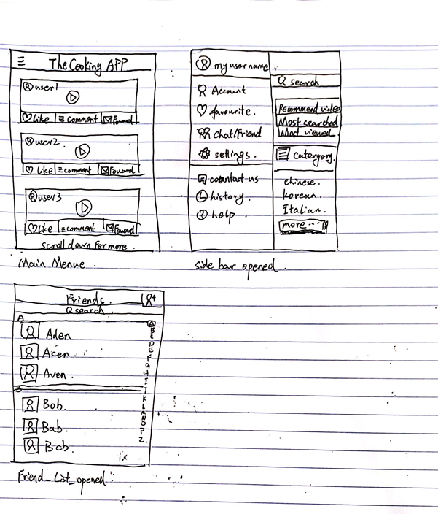

The side-bar design and main menu were two features of this design that the group really liked. The menu layout shown is clear and easy to use, allowing for maximised visibility (per Daniel Norman’s design principles). The side-bar, “hamburger” icon, is commonly used, example of an arbitrary icon which represents a hidden side-bar. This makes the feature user-friendly to both experienced and new users.

Some drawbacks of the design were that the side-bar layout was packed with too many features. It was decided that it would be beneficial to remove certain categories (i.e. video recommendation and search function) thus making sure the menu did not have too many options (as per Hick’s law). The main menu layout is also missing a navigation bar, which will be inserted during the developing stage for the purpose of consistency.

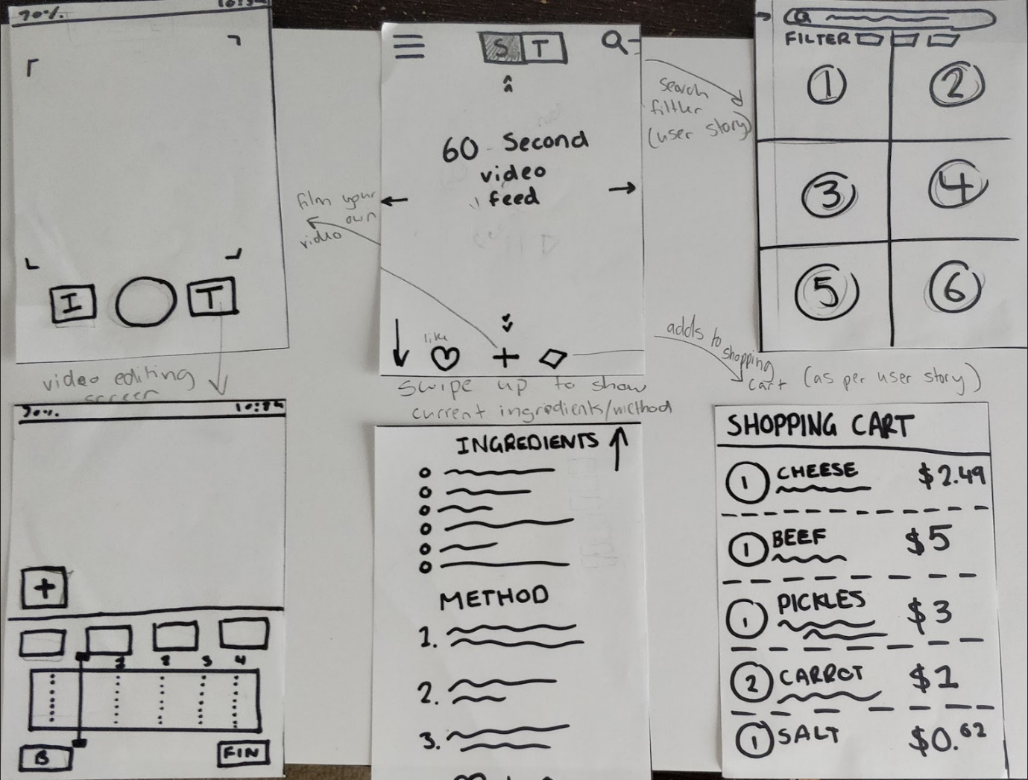

Attributes of the sketch that we liked as a group was the idea of using “ingredients” and “method” on the same page as the video and incorporating the implementation of ‘swipe’ to view recipe details. We also agreed to implement a search layout which featured both a categorizing technique and filter. Another element we agreed upon was the shopping cart.

Pros of sketch include having a fixed screen face (as per consistency), and interface design is commonly used in other apps. This positively draws on user’s mental models involving use of similar interfaces, making the app more user-friendly for both new and experienced users. This also complies with Schneiderman’s golden rules by providing consistency and reducing short-term memory load. Another pro is the shopping cart feature. This feature allows user to add recipe ingredients to a virtual shopping cart, making grocery shopping easier and more efficient. As this feature is already widely in use with online shopping, it draws on the user’s mental model to increase user satisfaction and learnability with the app. In addition, incorporating this feature makes the app unique, allowing it to be easily distinguished by users and giving the app an advantage over competitors in the market.

Some cons were that the recipe details layout should be more organised and informative (as per Gestalt’s Theory which utilises in particular the methods of typography and control blocks). This also applies to the shopping cart feature which is a little vague and limiting in terms of user options.

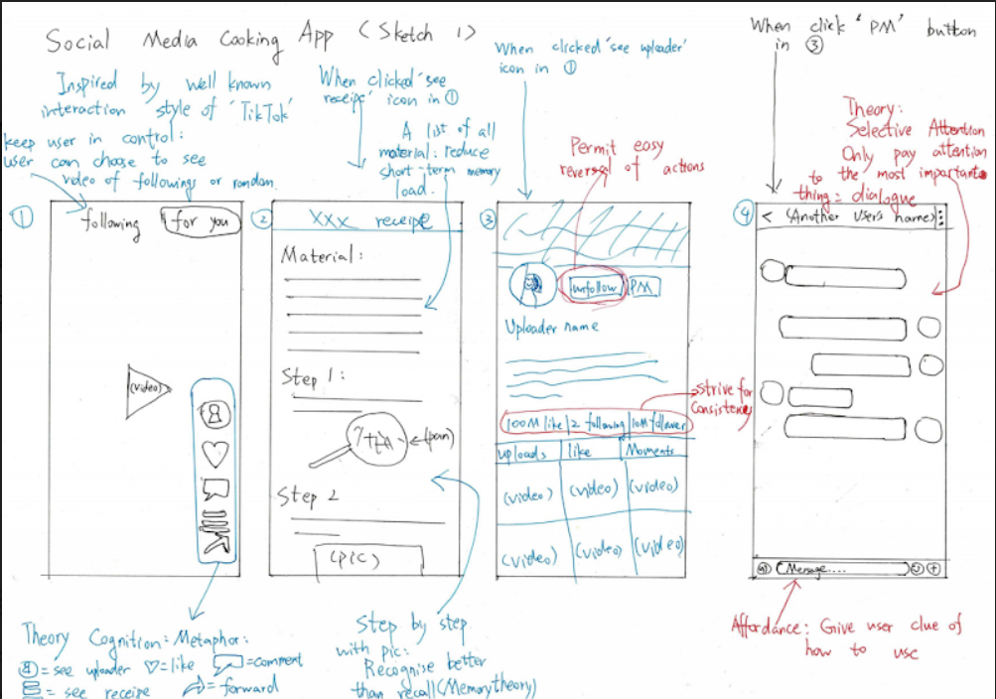

Features of this sketch that the group liked was that there was a thorough layout of the chat interface allowing us to clearly define how we wished to implement the chat function. A feature that many group members had implemented in their design sketches were the icons in the bottom right of the video layout, hence making it a feature we all agreed on.

A pro of this design is that interfaces are clear and informative, allowing greater understanding regarding the purpose of each layout. The sketch also uses multiple resemblance icons, symbolic icons etc. for example, “heart” represents “like”, which is already a primitive setting for app development, thus allowing the user to draw upon their mental models (as per Schneiderman’s golden rules, particularly involving consistency and seeking universal usability).

Similar to the sketch above, some aspects to work on would be making the recipe layout more informative and also including a navigation bar.

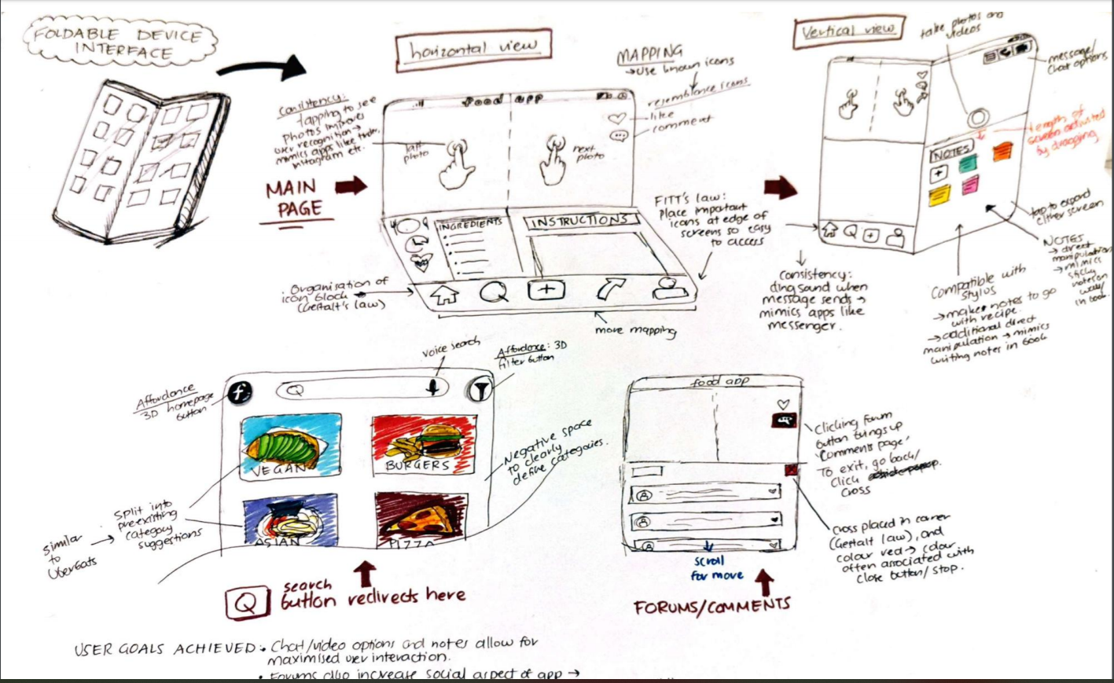

Aspects of this sketch that the team liked were the idea of incorporating recipe instructions and method on the same page. We also agreed upon having a chat feature which would allow users to communicate with other users on the app, hence achieving aims of making meal prep a more social and fun experience. Another feature the group agreed on was having a pop-up message implementation.

Pros of this design include placing an icon block at the bottom of the screen. As per Fitt’s law, this places important features at the edge of the screen, making them easier to access by users. The organisation of the icon block also complies with Gestalt’s law. Similar to other sketches, this sketch also uses icons (as per Daniel Norman’s design principles e.g. mapping). Search page also effectively organises content blocks and separates categories via negative space (as per Gestalt’s law).

Some areas of improvement include using visual affects to represent recipe information such as dietary requirements, nutrition, skill level etc. more clearly (as per Von Restorff effect). Another con is the lack of coherence and clarity in the organisation of the design (i.e. colours and layout). For consistency, it would be appropriate to use a defined colour palette, font, layout etc. In addition, this would also result in a more memorable experience for the user (as per the peak-end rule).

**SHARED USER STORIES**

USER STORIES:

PERSONAS:

TszKin

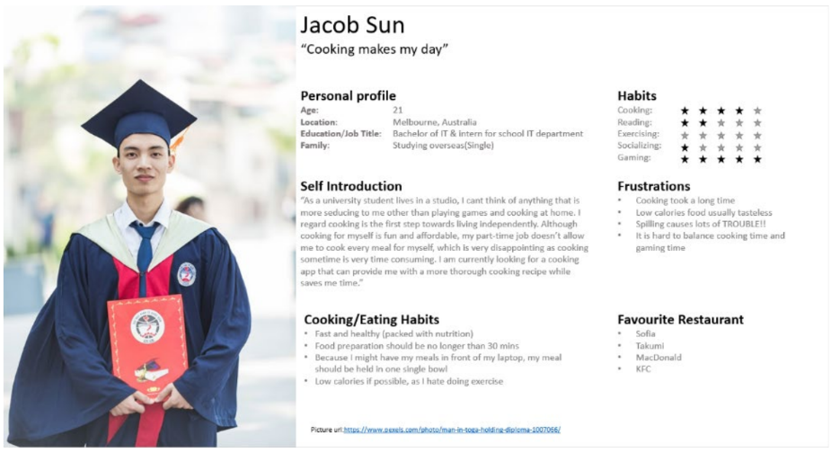

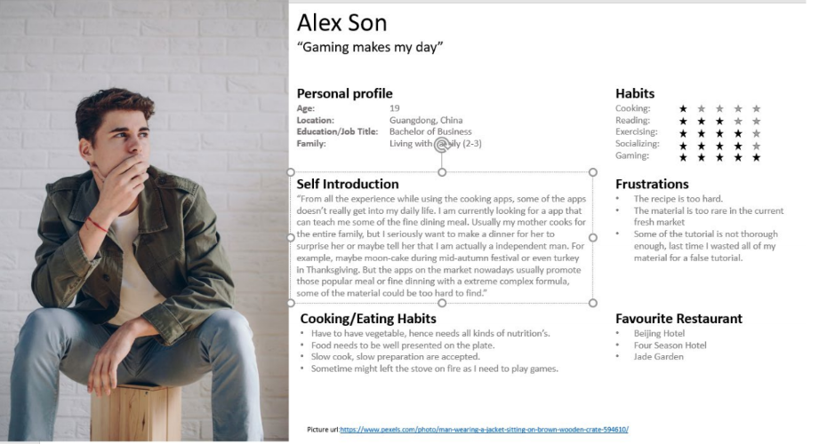

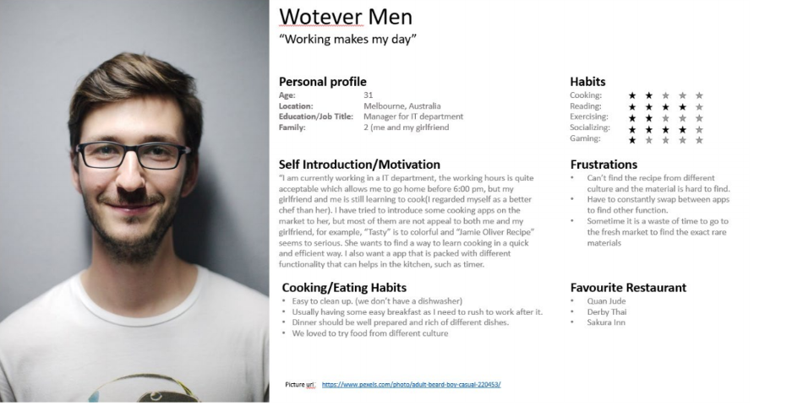

Kelvin

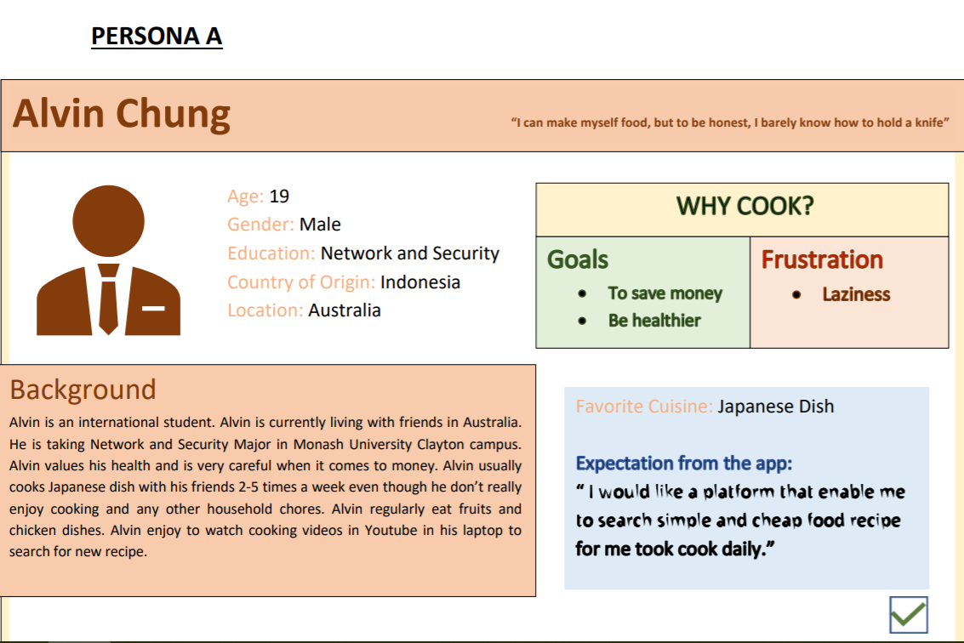

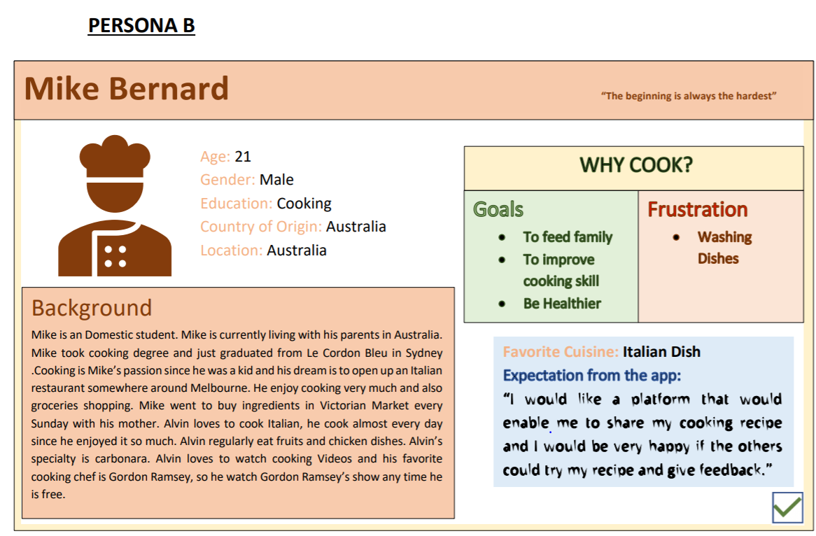

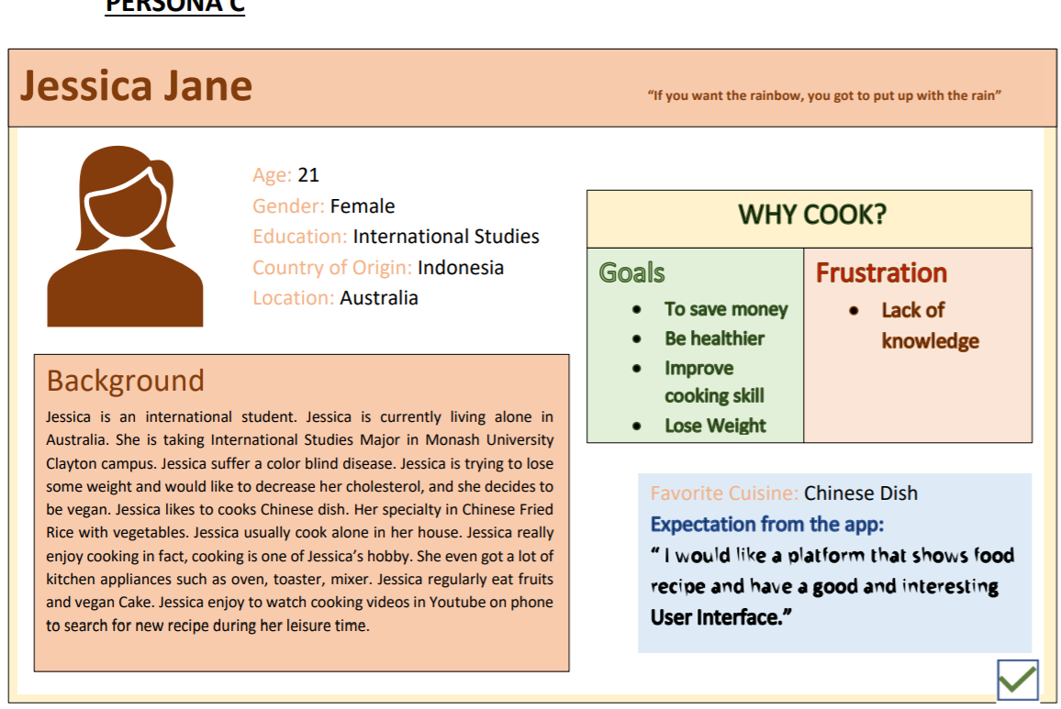

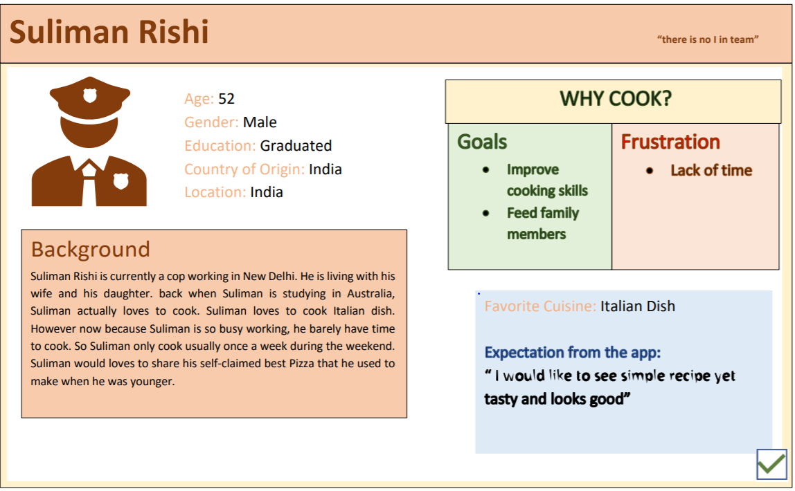

Michael

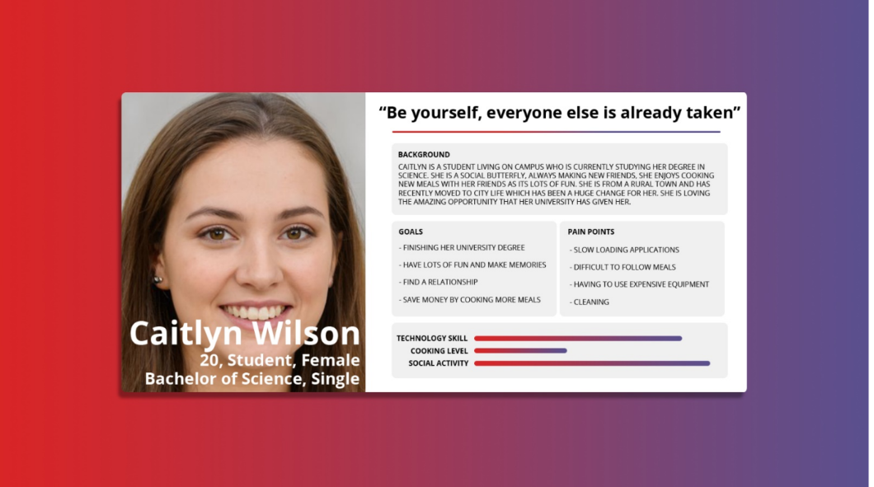

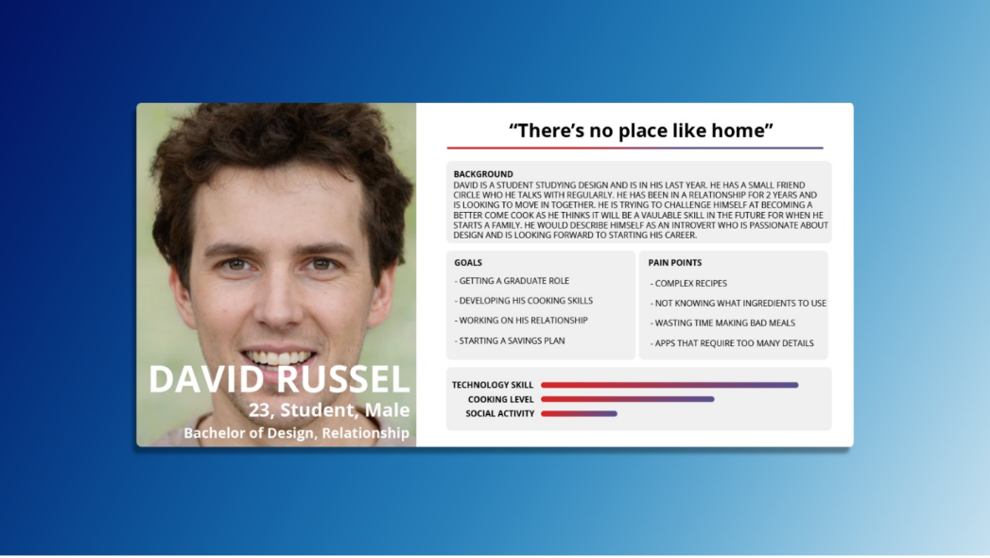

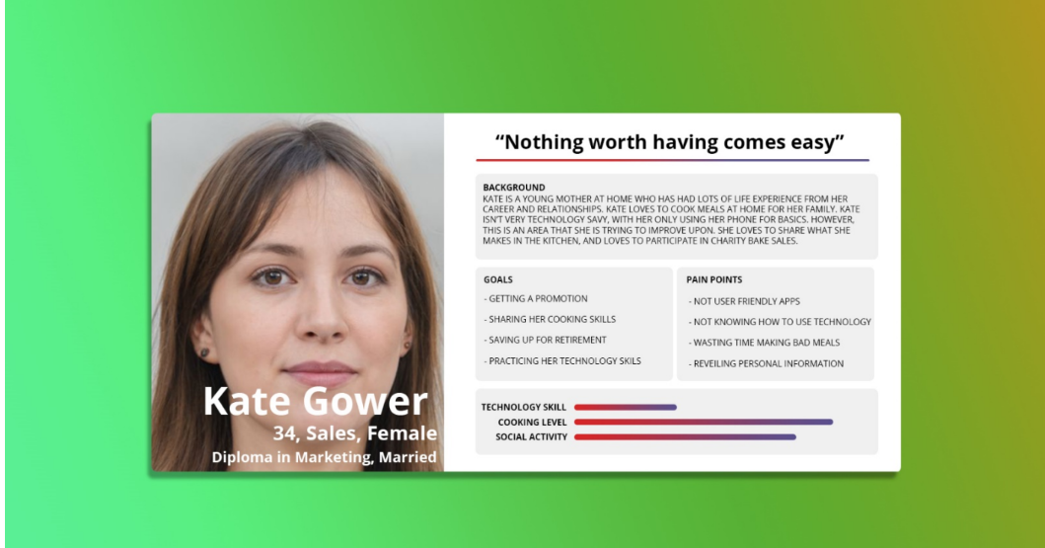

Zhi Hao Tan 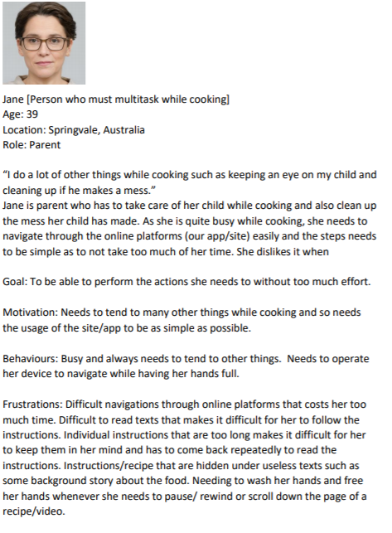

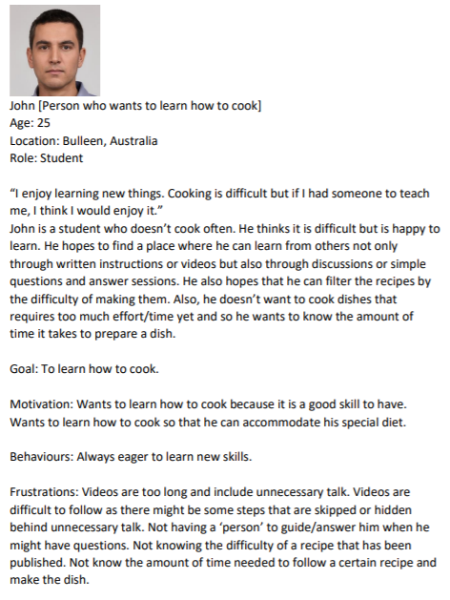

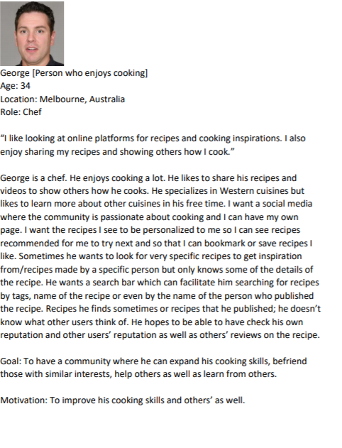

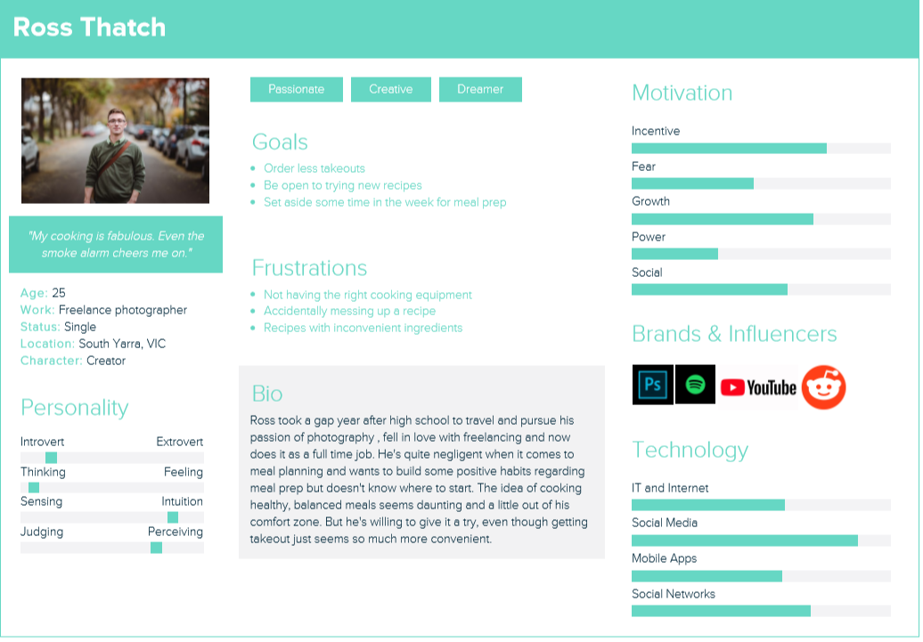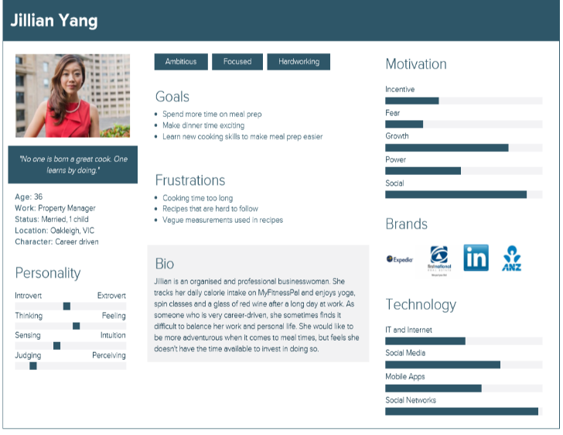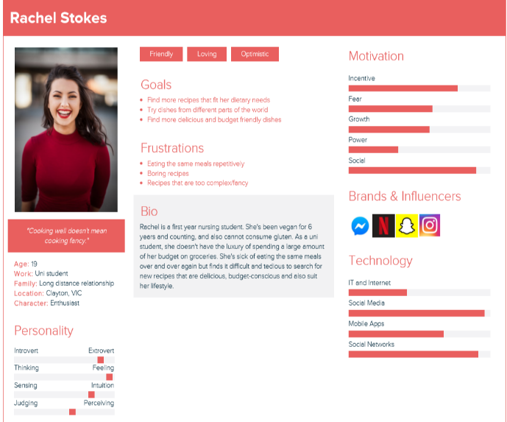Isha

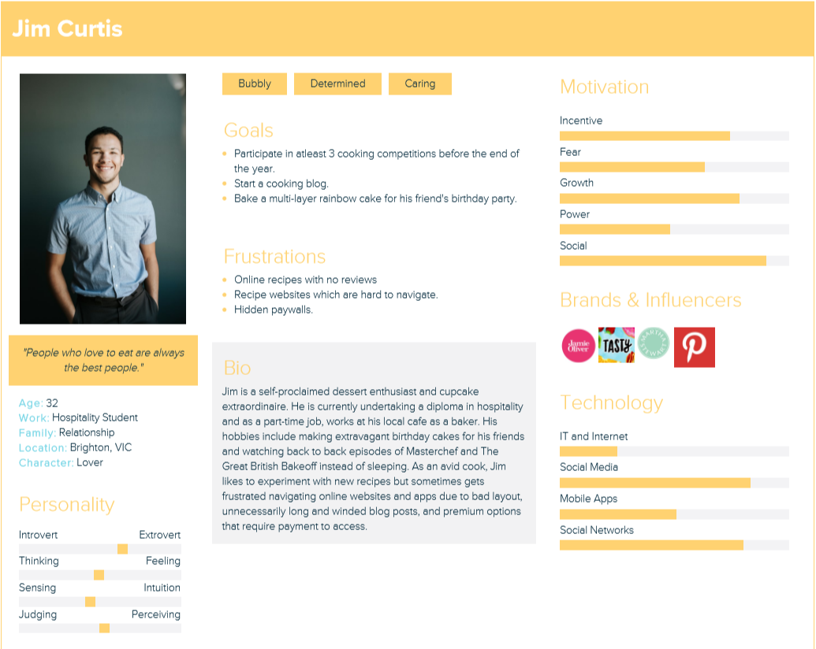

TO DO:

Draft up on drive

Finish reflections

One user story each

3 personas

Conclusion